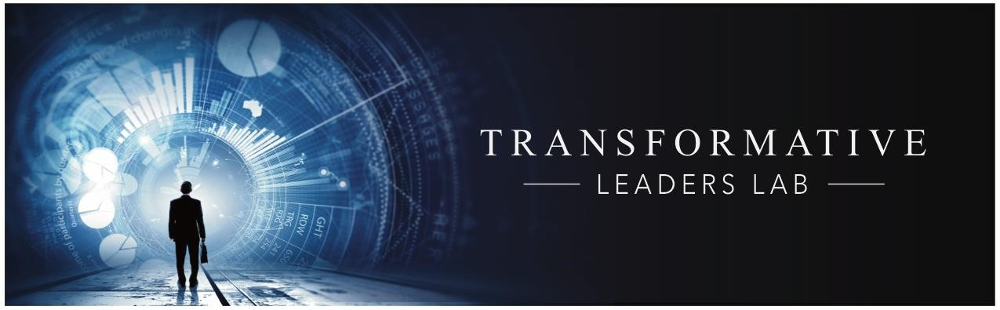

Transformation Leaders Lab – 7 modules

The LAB is designed to incorporate your personal values in your organizational transformation and realize a purposeful impact. It takes you outside your comfort zone to drive changes in your Mind-Set and organization’s culture necessary to propel Digital Transformation. The modules are interactive with cross-functional, intergenerational teams that encourage the discovery of new insights. These sessions generate takeaways that can be applied in your organization; they build upon each month’s previous experience.
- February 7, 2017- Module 1: Data, Media, Innovation... Roadmaps to Success in the Networked Economy

Guest speaker: Mark Malseed, Digital Entrepreneur, Media Innovator and
Bestselling Author of THE GOOGLE STORY

  - Discover Google's culture of innovation
  - Anticipate dynamically changing global economy ▪ Leverage data, search, information
- March 7, 2017 - Module 2: Are you a Transformative Leader?

o Takeaways ▪ Think Transformative ▪ Clarify your values ▪   Transforming leadership models
- March 21, 2017 - Module 3: Cultivating mindset transformation

o Takeaways ▪ Adopt transformative mindset and company culture ▪ Refine leadership skillset (e.g., Emotional Intelligence) ▪ Transform your values into organizational Value
- April 4, 2017 - Module 4: Fueling your purpose
  - Takeaways ▪ Revisit your purpose/mission statement ▪ Power strategies that integrate organizational purpose ▪ Generate stakeholder loyalty ▪ Create Shared Value across stakeholders

- May 2, 2017 - Module 5: Re-imagining business models
  - Takeaways ▪ Radically challenge your assumptions ▪ Sharpen Value Proposition and Unfair Advantage ▪ Prioritize Customer Experience ▪ Incorporate new economy and scale networks
- May 23, 2017 - Module 6: Structuring for change
  - Takeaways ▪ Increase employee loyalty & engagement & productivity ▪ Design outside unit to accelerate transformation ▪ Synergize collaboration across generations/functions ▪ Cultivate ongoing innovation

- June 6- Module 7: Driving Digital Transformation

  - Takeaways ▪ Leverage customer decision journey
    - Make data driven decisions ▪ Benchmark Digital
       ▪ Integrate social impact in determining ROI

Participants’ comments

“This is a great seminar for managers and supervisors looking for tools to innovate, spark changes and motivate employees to be more proactive. I gained insights on how new technologies impact our work environment and need for transformation.“ Nelson Nava, Chief Financial Officer, Humankind

“It was an engaging process, gained insights on mindset and refining our purpose. I appreciated the opportunity to step out of the “daily grind” and be encouraged the thinking bigger and deeper about myself as a leader and organization and its potentials and challenges.” Atefeh Leavitt, Program Director Legacy International

“Transformative Leadership Lab broadened my horizon and forced me to think bigger about the workplace and my role in it. It helped me to believe that I can be an agent of change- that it can start with me. It gave me insights into what needs to change in the culture of my organization and some ways to make movement toward these changes. “
Jim Meador, Outreach Coordinator, Humankind

“The workshop was eye-opening. My company is a transactional environment but what am I doing to drive change? Is our current decision-making process data-driven? This workshop made me reflect on our current projects and our ability to deliver on them. Are we actually implementing our lessons learned? Am I doing enough to raise the issues and cultivate action? Ashley Campbell, Cyber Security Administrator, BWX Technologies

“The Lab provides the skills necessary for future growth and success and dealing with disruption. For the first time in my many years at Humankind, I'm thinking about and exploring the true value of what my organization does and how we can do it more effectively." Juliette Whyte, Director of Adult Services, Humankind

